Tool Guide – Sublist3r

Introduction
A lightweight python tool useful for subdomain enumeration, it is used during the reconnaissance phase to query multiple public sources and expand the external attack surface. Since it mostly uses passive sources, Sublist3r is low-risk, and a useful first step in during reconnaissance.
Safety Disclaimer: Use only on networks and systems for which you have explicit authorisation. Unauthorized use of tools can be Illegal, unethical and harmful.

Setup and Launch
  - Step1: Open Deakin Detonator Toolkit
- Open Terminal in Linux
- Navigate to your Deakin Detonator Toolkit directory: (cd ~/Deakin-Detonator-Toolkit)
- Run DDT by using the following command line: (yarn run tauri dev)
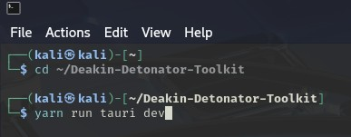
  - Step2: Find Tool-example
- Click on Tools to the left (or use the quick search bar)
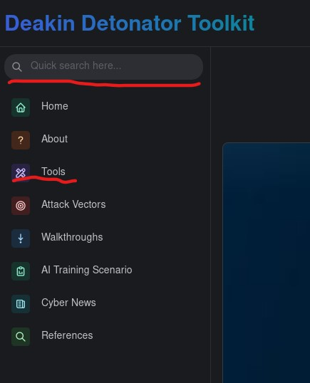
- If you clicked on Tools, scroll down and find Sublist3r and click go

Configuration and Usage
  - Step3: Configuring Sublist3r
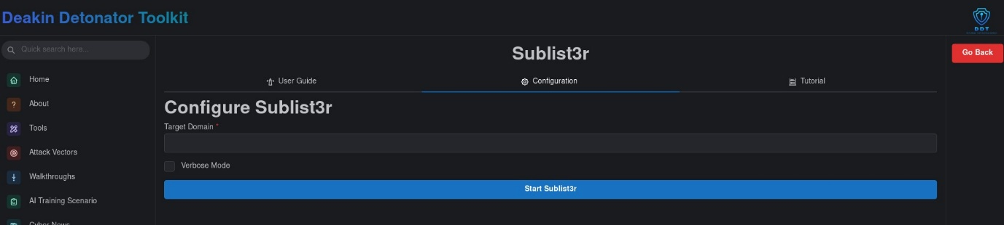
- Enter your target domain in the “Target Domain” field, e.g. “example.com”
- (optional) Turn on Verbose Mode, for additional information.
- Click on the “Start Sublist3r” button

  - Step4: Results
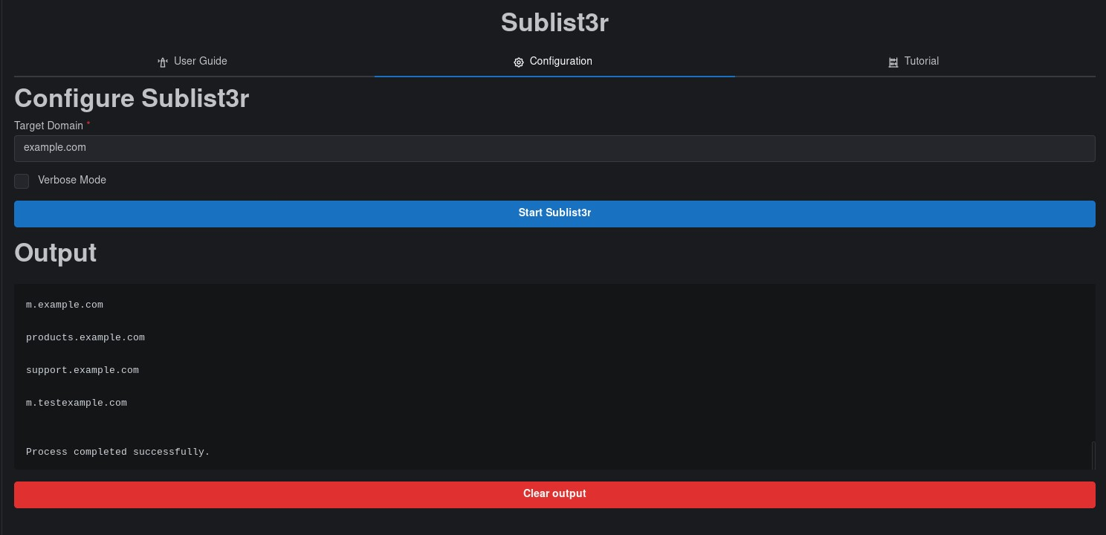
- You will be given an output that should end with “process completed successfully” and be sure to scroll up in the Output field to see the rest.
- Optional: You can save your output by filling out the new “Output filename” field with an appropriate name (output.txt) and then clicking “Save Output To File” button
- Optional: You can copy your output to your clipboard by clicking the little clipboard in the top-right of the output area.

Output Explanation
Note: your output will naturally be dependent on what domain you used and your settings, the following is non-comprehensive example output of what you could get from using Sublist3r on domain “example.com”.
- At the top you will see some Header ASCII art, alongside credits “Coded by Ahmed Aboul-Ela - @ aboul3la
- [-] Searching now in Google..
  - You will see multiple of these, showing where Sublist3r is querying.
- [!] Error: Virustotal probably now is blocking our requests
  - Sublist3r attempted to query “virustotal”, but was most likely blocked.
- [-] Total Unique Subdomains Found: 7
  - Sublist3r found 7 unique subdomains.
- AS207960 Test Intermediate - example.com
  - The Autonomous System Number (ASN) tied to a discovered IP.
- www.example.com
dev.example.com
m.example.com
products.example.com
support.example.com
m.testexample.com
  - a list of the subdomains, the discovery list.

